**Iteration 2 : Square Log Generation**

**[5 hours @ $30 / hr suggested]**

Using the input file : A39_2_MD5MEM_4MPR_7680-9647-page-012.csv

The primary task is to generate a square log

This version of the implementation should use the median point to determine the switch point from one value to another.

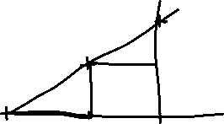

The black points are two points on the input curve.

The red line is the straight line between the two red points.

The equation of the red line is given by : y = mx + c

The green line is the output square log.

The input is pretty complex. You may want to do a first pass of the data to filter it using a low pass filter…

We must ensure not to filter too much to reduce the data content too much.

I would like a dialog box that allows the user to enter the filter parameters.

The input data should be displayed, along with the filtered data (different colors) and then finally the square log.

When the user is happy the data can be saved to an output square log.csv (depth / value).